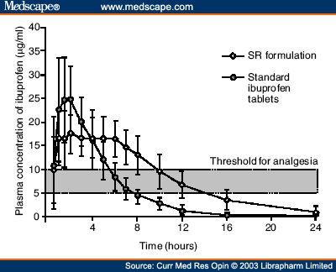

Figure 1.
Actual plasma concentrations of ibuprofen versus time after a single dose of the SR preparation and standard ibuprofen tablets. Volunteers were given single oral doses of the SR formulation (ibuprofen 600 mg and pseudoephedrine 90 mg) or standard ibuprofen tablets (ibuprofen 400 mg). Plasma levels of ibuprofen were measured pre-dose and at the given time points after dosing

http://www.medscape.com/viewarticle/466063_3

