**Managing Reputation Risk**

<https://deloitte.wsj.com/cmo/2017/07/24/managing-reputation-risk/>

*CMOs and other C-suite executives can develop reputational resilience by identifying potential risks and preparing plans before a crisis occurs.*

As Warren Buffett once said, “It takes 20 years to [build a reputation](https://www.forbes.com/pictures/eede45imgh/it-takes-20-years-to-bui/#7cf765eeec35) and five minutes to ruin it.” This can be especially true today, as high-profile crises including [cyberattacks](http://deloitte.wsj.com/cmo/2016/10/26/measuring-the-true-impact-of-a-cyberattack/), [product recalls](http://deloitte.wsj.com/cio/2015/08/13/the-prudence-of-quality-and-safety-analytics/), and [damaging social media posts](http://deloitte.wsj.com/cmo/2017/06/07/managing-risk-in-an-age-of-social-media/?mod=WSJBlog) become more prevalent. In this environment, protecting reputation and actively managing risk can take on strategic importance. Yet for many organizations, managing reputation presents challenges.

According to a recent Deloitte Dbrief webinar poll,¹ less than 15 percent of participating business professionals at companies across industries say their organizations have “optimized” to handle the reputational impact of a crisis (Figure 1) by investing in reputational risk planning and having strategies in place to address crises with explicit actions and processes. Less than one-quarter of senior leaders say their efforts are “maturing,” while more than one-third of senior leaders say their organizations are “somewhat” or “not very” equipped to handle a reputational crisis.

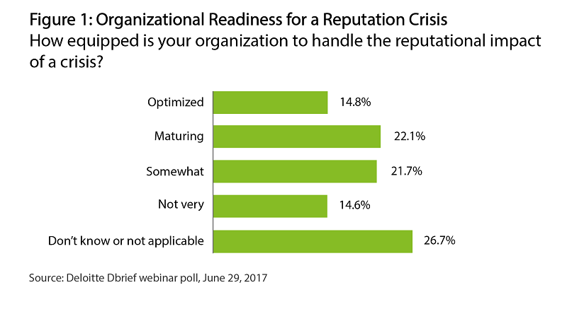

**Why Reputation Matters**

Reputation can be important, valuable, and frequently taken for granted. This is increasingly an issue for organizations, as the business value of reputation has grown significantly in the past few decades since the advent of 24/7 news coverage. According to a [study from Ocean Tomo](http://www.oceantomo.com/2015/03/04/2015-intangible-asset-market-value-study/), intangible assets like reputation account for more than three-quarters of a company’s market value today, compared with less than one-third in 1985. Although more than three-quarters of board directors surveyed in Deloitte’s 2016 study, [“A Crisis of Confidence,”](https://www2.deloitte.com/global/en/pages/risk/articles/a-crisis-of-confidence.html)believed their companies would respond effectively if a crisis struck, less than half said their companies have taken steps to be truly ready for a crisis.

When asked why organizations find it difficult to address reputational risk, 38 percent of respondents in the Dbrief poll said they are uncertain how to manage it (Figure 2). Just over 16 percent of respondents said they’re not sure who owns reputational risk, and nearly 16 percent cited cultural inertia.

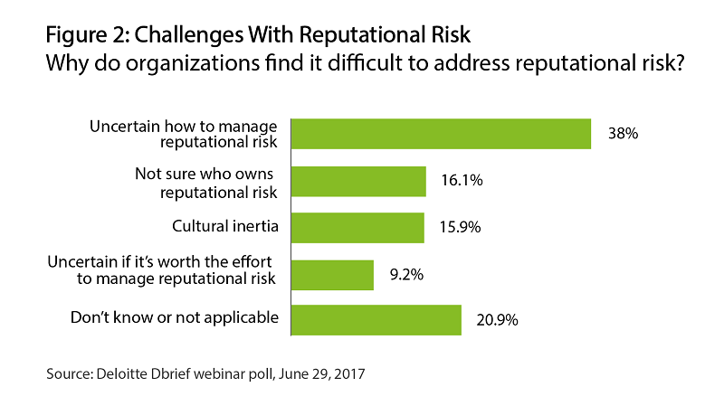

**Building Reputational Resilience**

So how can organizations develop reputational resilience before a crisis occurs? CMOs and other senior executives can take the following steps:

**Identify risks through a stakeholder lens.**Understanding stakeholders can be important for managing reputational risk. Many organizations have a diverse set of stakeholders—customers, prospects, employees, business partners, investors, analysts, regulators, and the general public. Senior leaders could benefit from considering internal and external stakeholder perspectives to identify the reputational impact of potential risks. For example, customers could affect a brand’s reputation by writing negative online reviews, and analysts could influence a company’s reputation through media commentary.

**Recognize reputational risk early.** Embedding risk sensing into an organization’s risk governance program can allow companies to continually identify emerging threats. To spot potential risks, many leading companies perform 24/7 monitoring of traditional and social media outlets as well as internal data sources. This can require a human- and technology-enabled capability that allows companies to analyze and interpret data to inform business decisions. Monitoring teams can support daily reputational threat sensing as well as the organization’s crisis management response process.

**Establish a risk governance structure.** Managing reputational risk doesn’t typically fit neatly into a single function. Ultimately governed by the board, reputational risk management may require clear accountability, leadership, and engagement across numerous teams. These teams may include marketing, risk, internal and external communications, human resources, and operations. Companies can benefit from recognizing the critical role of the CEO in setting the tone at the top and identifying cross-functional leadership across all business units that interact with key stakeholders. According to the Deloitte Dbrief poll, the CEO serves as the chief reputation officer at just over one-quarter of companies surveyed (Figure 3). The CMO or other marketing/communication officer is responsible for reputational risk at approximately 15 percent of companies surveyed, while the chief risk officer is responsible for managing reputational risk at about 10 percent of companies.

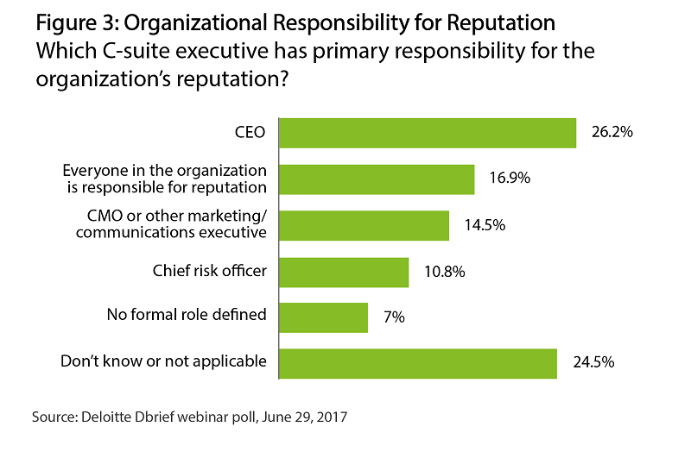

**Prioritize reputational risk as a key strategy.**Reputational risk exposure is often continually changing, presenting both threats and opportunities. Organizations can be better prepared by considering future trends and anticipating potential long-term reputational impacts. This approach recognizes reputational risk as a significant strategic consideration. Facing future risks may require major internal changes. These changes may be best made as part of a well-managed plan rather than a knee-jerk response to a reputation-damaging event.

**Formalize a crisis response program and practice.**Effective management of a crisis event can mitigate potential reputational damage. Establishing an effective crisis management framework can allow organizations to integrate the right processes, roles, and governance into existing contingency plans. Knowing when to mobilize a crisis response, how to manage decision-making, what information to communicate to which stakeholders, and how to coordinate communications across different teams often takes practice. Companies can test processes and gain experience by running crisis simulation rehearsals based on the most critical reputational risks.

**Execute the plan.** Reputation-damaging events often start as issues that grow into major crises as information emerges and the implications become clear. This sequence can unfold very quickly, and very visibly. During a crisis, there are commonly two parallel priorities—containing and resolving the issue at hand, and addressing short- and long-term reputational risk. Both can require swift decision-making, responsive communications through multiple channels, and a consistent narrative that addresses the issues most important to various stakeholders.

**Follow through.** After the initial response to a crisis, the recovery program may take months or years. Making public commitments, such as pledging to implement new safety programs—and delivering on them—is often important for rebuilding trust and reputation.

**\*\*\*\*\***

Reputation is among an organization’s most cherished assets. It can be affected by stakeholders’ perceptions of how a company manages its daily business operations, and how it responds in a crisis. CMOs and other senior leaders can work to mitigate risk and repair reputational damage when it occurs by establishing an effective crisis response and recovery program. Building a strong, positive reputation can generate long-term value in brand equity, intellectual capital, sustained earnings, and future growth.

*—by Keri Calagna, advisory principal, Deloitte Risk and Financial Advisory, Deloitte & Touche LLP; and Matthew Davy, senior manager, strategy & operations, Monitor Deloitte UK*