What is Reputational Risk and How to Manage it

[**JONAS SICKLER**](https://www.reputationmanagement.com/about/team/jonas-sickler/)**FEBRUARY 8, 2019 UPDATED AUGUST 12, 2019**

<https://www.reputationmanagement.com/blog/reputational-risk/>

*C-suite executives and board directors believe reputational risk poses the greatest strategic threat to businesses. It can wipe out billions of dollars in market capitalization and impose sweeping changes to company leadership. But what does it mean and how do you manage it?*

*In this article, I’ll define reputational risk and explain how it impacts your business. I’ll also show you several easy steps to measure and manage it.*

What is reputational risk?

By definition, **reputational risk** refers to the potential for negative publicity, public perception or uncontrollable events to have an adverse impact on a [company’s reputation](https://www.reputationmanagement.com/blog/negative-company-reputation-affects-business/), thereby affecting its revenue.

Reputational risk strikes without warning. It shifts your corporate landscape, impacts revenue and sparks chaos. Even worse, it affects customer opinions and organic traffic by weaving negative content into your search results.

We have years of experience helping large financial services companies take control of their search landscapes. Curious about our results? Explore our [reputation management case studies](https://www.reputationmanagement.com/case-studies/) page, or read these individual ORM and SEO case studies:

* [Fortune 500 CEO](https://www.reputationmanagement.com/case-studies/fortune-500-ceo-orm-case-study/) Flipped Top 50 Search Results from Negative to Positive
* [Billion Dollar Company](https://www.reputationmanagement.com/case-studies/furniture-retailer-orm-case-study/) Recovers $32.7 Million Monthly
* [Student Loan Refinancing Provider](https://www.reputationmanagement.com/case-studies/student-loan-refinancing-provider/) Increased Google Rankings by 1,081%
* [Leading Mortgage Company](https://www.reputationmanagement.com/case-studies/mortgage-company-seo-case-study/) Grew Blog Traffic by 113,000 Within 2 Months

**Reputation risk vs. risk management and strategic risk**

Unfortunately, reputational risk is often neglected or confused with other types of corporate risk. Let’s look at how they all relate to one another.

*Enterprise risk management* is the process of minimizing the costs and damage of *strategic risk*. Board directors and C-suites understand strategic risk because it’s specific, measurable and predictable, therefore it is controllable.

*Reputation risk*, on the other hand, is largely unpredictable. In fact, it can even be tied to events that aren’t your company’s fault. Still, opinions of clients, investors, business partners and the general public can have a profound impact on your firm’s revenue. Therefore it’s critical to be aware of hazards that cause business reputation damage.

[Contact our team to set up a call](https://www.reputationmanagement.com/contact-us/). We’ll explain how we help investment firms and financial services companies establish and restore their online reputations.

Types and causes of reputational risk

There are numerous types of risk to guard against, including outside adverse events, workplace practices, data retention failures, product recalls, bad financial statements, and [CEO reputation issues](https://www.reputationmanagement.com/blog/reputation-management-for-ceos/). Let’s dive into the scenarios that pose the greatest threat.

**Negative articles**

Lawsuits, scandals and regulatory penalties can impact revenue for years if negative content remains in your search results for potential customers to discover. Whether brought on by unsettled employee disputes, customer complaints or regulation violations, negative media attention can shackle profits for global banks and financial services companies.

Maybe an old article won’t go away. Or perhaps something from the past resurfaced and triggered a fresh round of bad press.

Whatever it is, we can help.

**Bad reviews**

Negative reviews hurt financial institutions more than you might think. Maybe an industry expert wrote a scathing review of your bank that detailed lawsuits and hundreds of customer complaints.

Or perhaps customers or employees left a few bad reviews and you don’t have enough positive reviews to balance them out. As a result, you have a 3/5 star review on the first page of your search results.

It’s imperative to deal with these issues to prevent further revenue loss.

**Social media**

Social media can be both a cause and a catalyst for a negative reputation. When company leaders post controversial comments online, their statements affect the entire business, not just the [executive’s reputation](https://www.reputationmanagement.com/blog/reputation-management-for-ceos/).

Additionally, unsolicited brand mentions by influential political figures or celebrities can also lead to social media backlash. Although your company may have been casually mentioned, the public will likely infer a reciprocal endorsement.

Furthermore, social networks can amplify negative press that may otherwise have gone unnoticed.

**Employees**

Company leaders aren’t the sole source of reputational risk; any of your employees could spark public outrage. Imagine the consequences in each of the following scenarios:

* A bank teller or branch manager calls the police for racially motivated reasons
* One of your wealth managers refuses to serve a gay couple
* A director at your VC firm is accused of sexual misconduct

Any of those situations could cause a viral news cycle that results in boycotts, customer defection, and significant revenue loss for years.

**Services and pricing**

Whatever your business model, if your company underperforms or overcharges, it will eventually develop a bad reputation. For example, a journalist may publish an expose about shady sales techniques or reveal hidden fees. Or a financial analyst could write a damaging article about the quality of your investment funds.

**Data loss**

Your customers trust you with their data. In fact, finance companies handle some of the most sensitive personal information, including: names, social security numbers, passwords, logins, pin numbers and bank account numbers. A data breach will corrode your institution’s reputation and could cost you [hundreds of millions](https://www.pymnts.com/news/security-and-risk/2018/equifax-cost-275m/) of dollars.

**Regulation changes**

Government regulations can change with each election cycle. Under one administration your bank may meet stress test requirements, and under another you could face liquidity risk. When the public thinks your financial institution is unstable, they’ll take their money to your competitors.

Reputational damage

Your business’s reputation is your most valuable asset, especially if you’re a bank or financial institution.

A negative [corporate reputation](https://www.reputationmanagement.com/blog/corporate-reputation-management-strategies-for-brands/) harms client and investor trust, erodes your customer base and hinders sales. A poor reputation also correlates with increased costs for hiring and retention which degrades operating margins and prevents higher returns.

Furthermore, business reputation damage increases liquidity risk which impacts stock price and ultimately slashes market capitalization.

Reputational risk examples for banks

Wells Fargo is probably the best example of the impact of reputational risk. The bank’s employees opened millions of fake accounts, overcharged for mortgage insurance, signed up customers for unnecessary car and pet insurance and accidentally foreclosed on hundreds of homes.

Those actions prompted the bank to take the following actions to mitigate reputational risk:

* Fired 5,300 workers
* Replaced longtime CEO
* Replaced board chairman and directors
* Paid $185 million to atone for shady sales practices
* Reserved $285 million to refund wealth-management clients for pricing and fees

*“There’s no question that Wells Fargo’s scandals are responsible for seriously eroding shareholder value.”*

***William Klepper****, management professor at Columbia Business School*

As a result, the wealth and investment management unit has struggled to generate new business. The Federal Reserve also [limited](https://www.forbes.com/sites/robertlenzner/2018/06/29/wells-fargo-stages-a-reputation-comeback-can-it-convince-the-fed-its-changed/#fd1b47ba15a3) Wells Fargo’s growth until the bank changes its management and risk control procedures.

Next, let’s look at some reputation risk management best practices.

Four steps of reputation risk management

It’s important to develop a framework for managing reputational risk prior to an issue. The following steps will help you measure, monitor, manage and mitigate damage to your reputation.

**1. Measuring reputational risk**

Step one is to execute a reputational risk assessment to establish the baseline for your company’s image. That will help you determine public perception of your company and competitors as well as the industry in which you operate.

Reputational risk is highly subjective so segment your stakeholders into separate groups to determine areas of exposure. You may want to include regulators, analysts, investors, clients or employees.

Next, indicate the level of danger for each segment. For example, you may use a numeric scale or colors. See the **reputational risk assessment template** below:

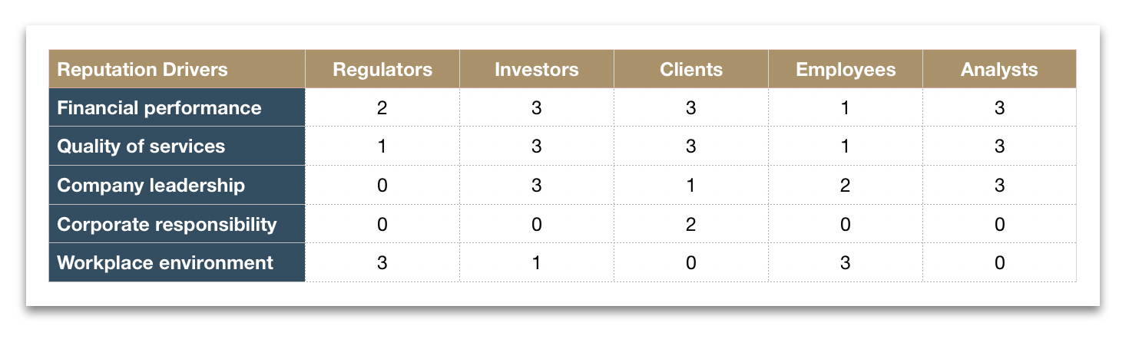

Finally, take inventory of each groups’ perception of your company. This can be accomplished through internal and external surveys or search engines.

All media outlets worth their salt have an online presence, so search engines are incredibly useful reputational risk assessment tools. However, brand sentiment analysis isn’t as easy as popping your organization’s name into Google. Some [negative articles](https://www.reputationmanagement.com/blog/how-to-remove-negative-search-results/) may lurk in the dark web and won’t surface in a traditional search.

It’s best to enlist the help of [online reputation management services](https://www.reputationmanagement.com/blog/best-online-reputation-management-services-and-companies/) like our company to help you quantify reputational risk.

If you’d like to tackle the task on your own, you should track your first 500 search results. Paste them into a spreadsheet and classify them as positive, neutral or negative. Then, use a **reputational risk assessment matrix** like the one below to designate the severity of all neutral and negative content.

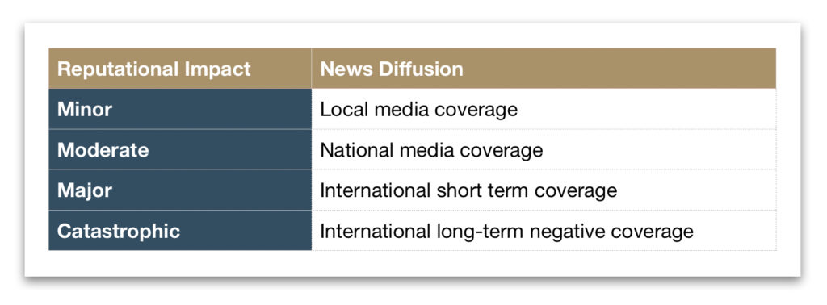

**2. Managing reputational risk**

Use your assessment as a framework to develop a reputational risk management plan. You may need to create more than one process or strategy depending upon the type of risk your firm is exposed to.

For example, racial discrimination accusations will require a different approach than customer complaints or inappropriate CEO comments on social media.

It’s impossible to offer specific recommendations for this step because there are an infinite number of possibilities. Ultimately, it’s best to work with a [crisis management](https://www.reputationmanagement.com/blog/crisis-management/) firm or public relations agency to resolve an active crisis as quickly as possible.

**3. How to mitigate reputational risk**

Once your situation is under control, you’ll need to mitigate the damage to your brand’s image through [online reputation management](https://www.reputationmanagement.com/blog/online-reputation-management-guide/). That process involves mapping and expanding your online presence to reflect your company’s most positive digital assets.

However, it’s no small feat to influence your Google results. You must execute social media management, [brand management](https://www.reputationmanagement.com/blog/what-is-brand-management/) and most importantly search engine optimization. The importance of working with ORM experts cannot be overstated.

In addition, firms should run [reputation marketing campaigns](https://www.reputationmanagement.com/blog/what-is-reputation-marketing/) to shift the negative narrative and repair damage. Use those campaigns to promote your company’s [corporate social responsibility](https://www.reputationmanagement.com/blog/corporate-social-responsibility-examples/) programs (CSR).

**4. Monitor your reputation**

The final step in a reputational risk management program is to diligently track brand perception against your baseline. Monitor opinions of employees, customers, vendors, shareholders, analysts and activists. Here are just a few ways you can continuously monitor brand reputation:

* Run surveys
* Hire a brand sentiment tracking agency
* [Set up Google alerts](https://www.reputationmanagement.com/blog/how-to-set-up-a-google-alert-for-your-brand/)
* Manually search your brand and your executives Google
* Work with a reputation management company like us

Reputational risk insurance policies

Reputational risk is a massive expense that squeezes your bottom line. What’s worse, it may even go undetected for years. Because it poses such a substantial threat, firms weigh the benefit of taking out a reputational risk insurance policy.

While insurance can help pay for the cost of a damaged brand image, it won’t fix the underlying issue. Therefore, is the cost really worth it? Rather than wasting capital on reputation risk insurance, consider strengthening your online presence instead.

[Contact us](https://www.reputationmanagement.com/contact-us/) and we’ll develop a plan to manage your reputation and [protect your company](https://www.reputationmanagement.com/blog/reputation-protection/) for the long haul.